# CS 255 System Design Document Template

## UML Diagrams

### UML Use Case Diagram

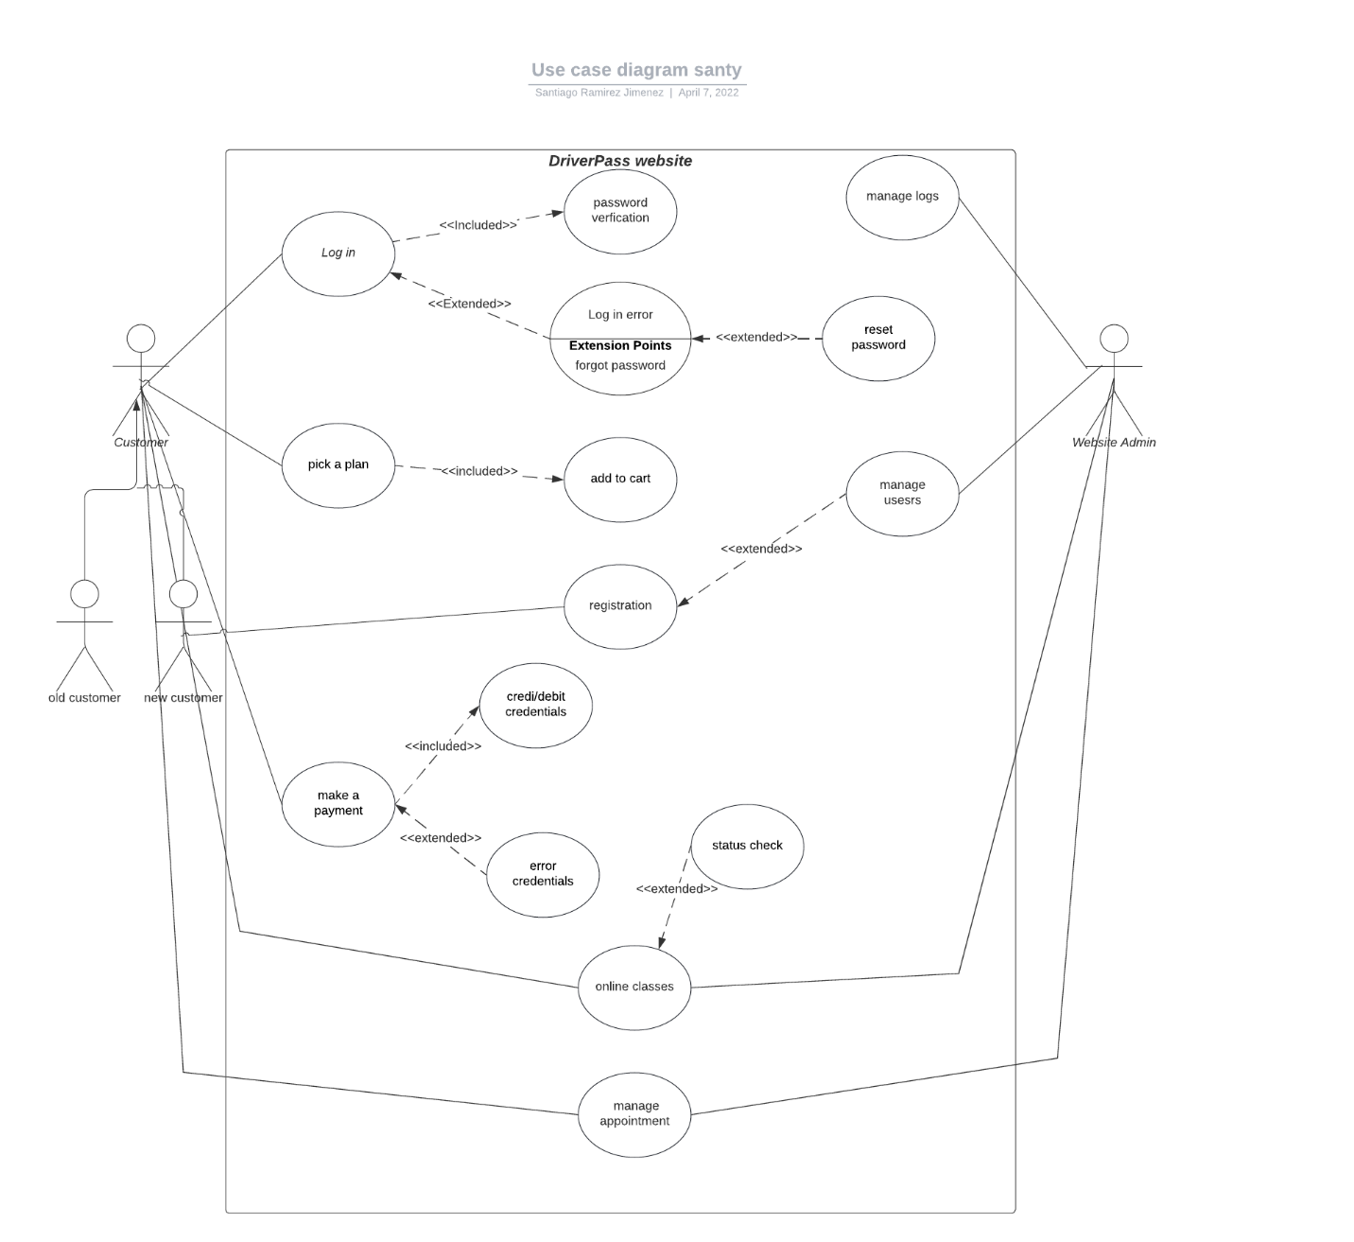

### UML Activity Diagrams

*[You were asked to choose* ***two*** *use cases and create* ***two*** *activity diagrams, one for each use case. Please*

*insert* ***both*** *of your activity diagrams here. Check to make sure that you included appropriate components and symbols and that your design meets the client’s needs.]*

*customer:*

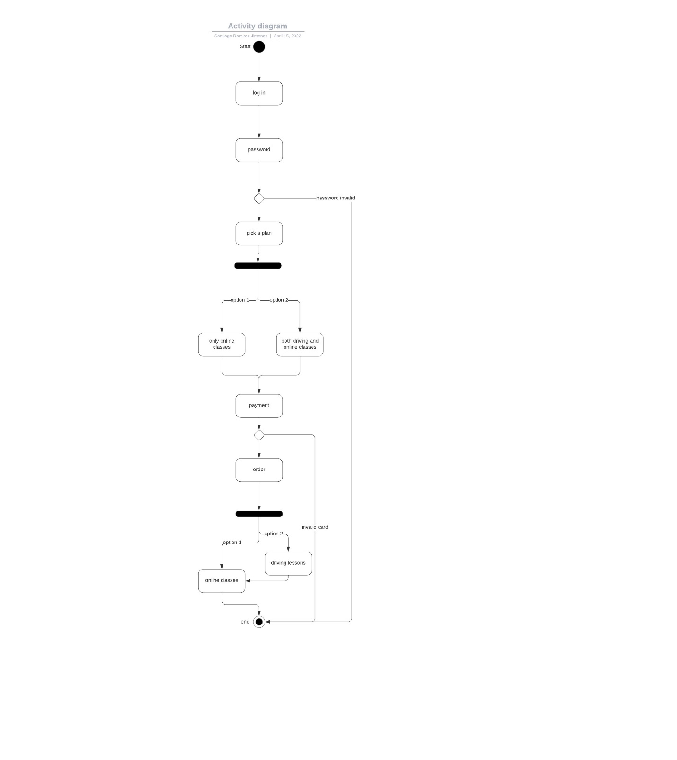

*Admin:*

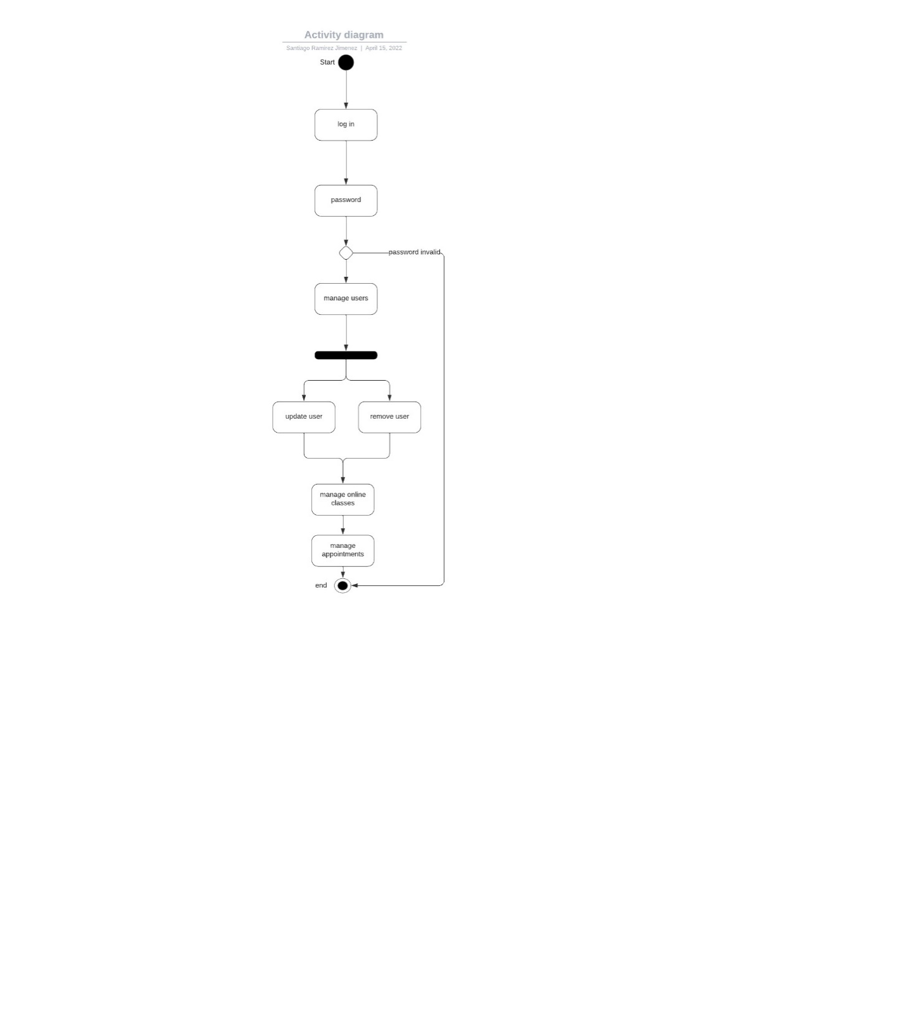

### UML Sequence Diagram

*[You were asked to create a sequence diagram based on* ***one*** *of the use cases you chose. Please insert your sequence diagram here. Check to make sure that you included appropriate components and symbols and that your design meets the client’s needs.]*

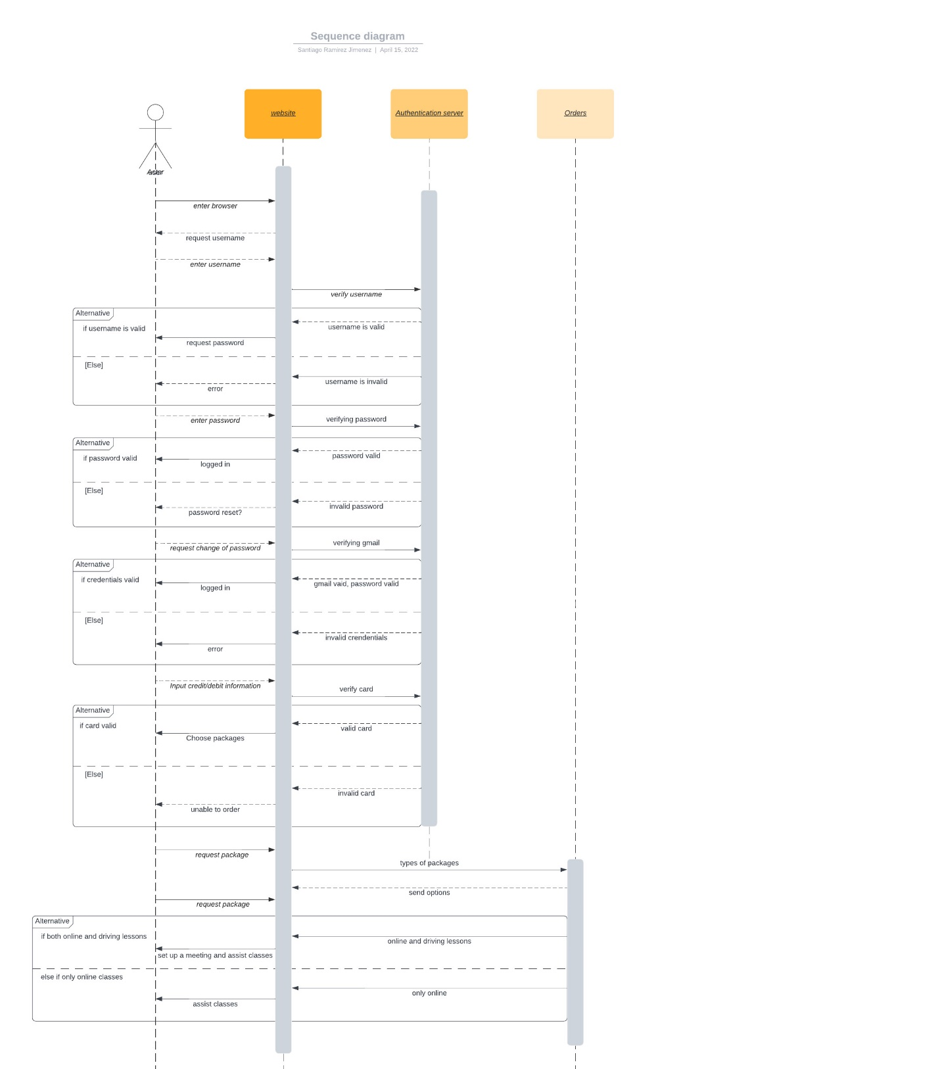

### UML Class Diagram

*[You were asked to create a class diagram based on the different classes and attributes needed for your system design. You are* ***not*** *required to include methods, but you may if you wish. Please insert your class diagram here. Check to make sure that you included appropriate components and symbols and that your design meets the client’s requirements.]*

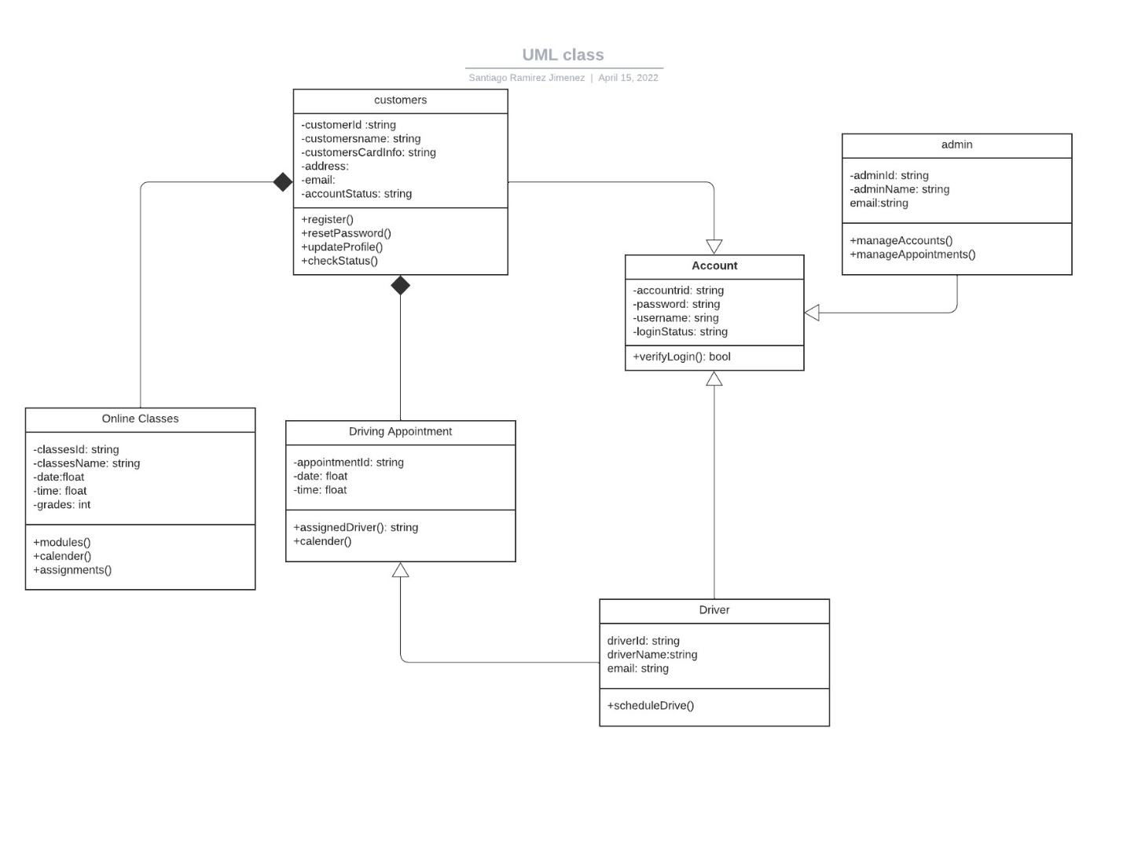

## Technical Requirements

*[Based on the diagrams you have created, describe the technical requirements of your system. These requirements should address the required hardware, software, tools, and infrastructure necessary for your system design.]*

The technical requirements for my system based on the diagrams created are:

Hardware:

Performance is a key technical requirement when building a system and in this case the system itself needs the necessary hardware to make the system performance more efficient and sustainable. The hardware of the system should be taken care through the cloud so the technical requirement of performance wouldn’t really have a negative affect on the system and therefor will run with the highest performance possible. In previous diagrams we can see a bit of the representation of performance within the system because it demonstrates the way that it allows for the system to run properly with no performance issues such as how the activity and sequence diagram portrays the necessary steps the system has to go through in order for it to have a consistent performance without having issues in regards to hardware.

Software:

When using software it is important to have serviceability which is a technical requirement that allows for the system to constantly be updated and my system itself needs to updated frequently to acquired newer and improved online classes that will make it possible for users to adapt to newer exams. The class diagram shows the serviceability of the system because it gives a picture of how the admin has to constantly be taken care of the users in the system by constantly updating and removing users. Also the authentication software in the sequence diagram illustrates how effective it is with maintaining the software integrity which is another technical requirement called maintainability.

Tools:

The tools such as the authentication and authorization which is another technical requirement that was also mention before, allows for the system to have the proper measures of allowing users into its system and this can be shown in the sequence diagram where it demonstrates how authentication has an important role in the system by giving the proper steps that are necessary for the user to enter its server through the client as well as the authentication of the payments that are allow in order to receive the website services.

Infrastructure:

The infrastructure such as the internal controls which is another technical requirement that is shown within the system and it is demonstrated in the use case diagram that shows every actors role and its internal control of the system and how they interact with the system so therefor it gives a proper understanding of the infrastructure that allows the system to run properly. The internal controls with actors such as the customer has little internal control of the system which can only allow the customer to be able to receive online classes, create an account and make appointments. Additionally, the admin has full control over the system and is capable of doing duties such as managing accounts/user, managing classes and appointments.